**unit 3-3.6**

**Different elements to control environments for collaborative technologies.**

**Below is a draft of the text and editing carried out with some of my classmates, for the exercise 3.5.**

**There is a link for myself to ask anna (owner), for permission to edit the shared file, and the draft shows our contributions, identified with a (-kj), after each sentence.**

**There are also comments attached to where we entered extra messages.**

## 3.6

For this exercise we are asked to add;

* ~~Themes-[choose page colour, formatting, watermark]~~
* ~~HTML text~~
  + ~~Logos~~
  + ~~Links~~
  + ~~Maps~~
  + ~~Videos~~

***I have added a watermark to the document, which also is used as my logo.***



This document is being composed with Google Docs as the processor, to get a description of Google Docs, I have researched on Wikipedia;

This is the link

[Google Docs - Wikipedia](https://en.wikipedia.org/wiki/Google_Docs)

Google who own this web site are based in Mountain View, Santa Clara County, California,

map-[Mountain View](https://goo.gl/maps/K3B9piErrtWBVDzL9)

[Inside Google's Massive Headquarters](https://youtu.be/Z-pT0XDYvDM)-video

***If this was a web page, the code to embed the video would be the following;***

<iframe width="560" height="315" src="https://www.youtube.com/embed/Z-pT0XDYvDM" title="YouTube video player" frameborder="0" allow="accelerometer; autoplay; clipboard-write; encrypted-media; gyroscope; picture-in-picture" allowfullscreen></iframe>

My first Google Doc

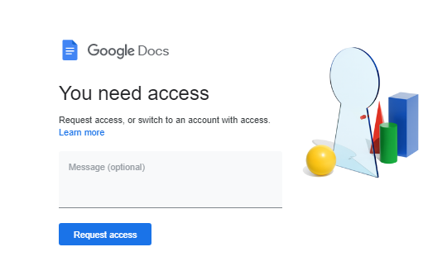

Hello Keith! :) - Anna

Hi up

You’re armadillo=kj

I’m assuming everyone else should be able to access your file now. - Anna

Brilliant! At least you can see the animals I was on about now. Lol - Anna

This is a ood method og communication, still think Teams is best-kj

For this particular exercise, I think Teams + Google docs would’ve been great! - Anna

Google docs , good idea for writing a group document, where we all add our bit-kj

I agree. We can even do this on spreadsheet (Google Sheets) and fill in the units we’ve completed all in one file.- Anna

Anyway, I’ve got to shoot off to my real job now, but this has been fun. I’ll catch you later. :)

- Anna

bye